**Connection instruction to Xiaomi Mi Electric Scooter**

This document has a step by step instruction on how to set up Mooving IoT device on Xiaomi Mi Electric Scooter.

1) First of all, you need to turn off your scooter. After that, you have to disassemble the scooter’s bottom lid. For this operation you will need a Torx screwdriver.

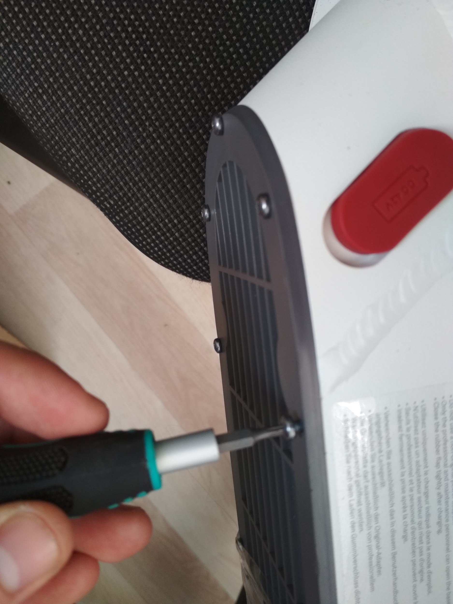

After you take off the bottom lid you will be able to see the battery (right) and main circuit board (Left).

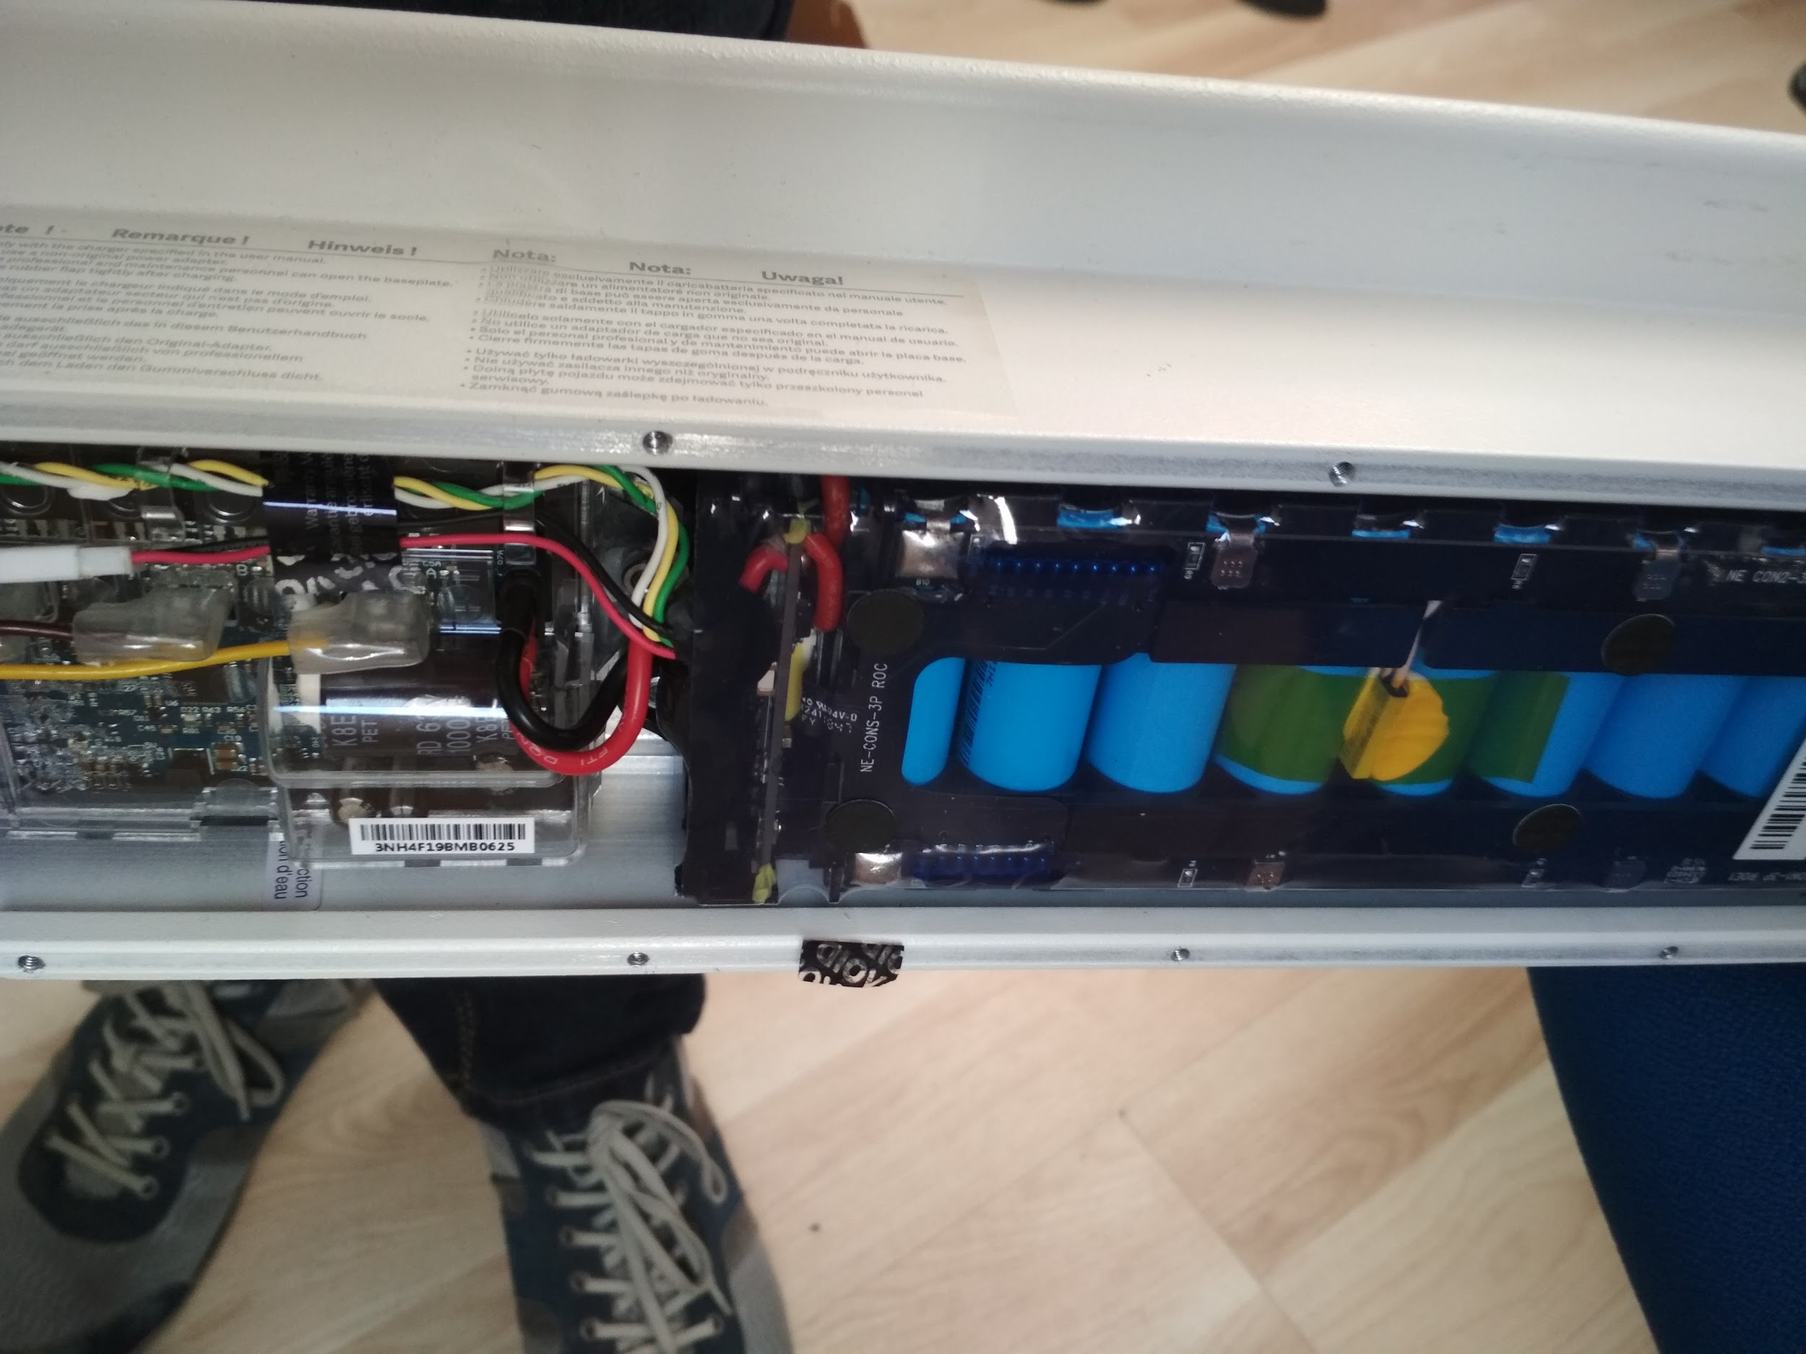

2) Pull out the battery connector from the main circuit board.



3) Make a hole in the rear part of the bottom lid. Then pass all wires from Mooving IoT device through this hole. Wires should go from the outside to inside the scooter.

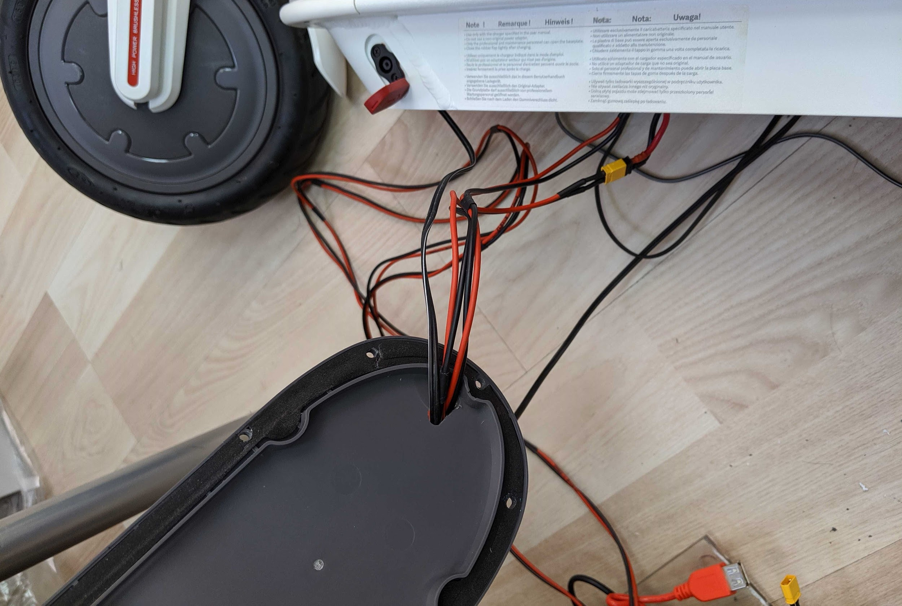

4) Connect power wires from Mooving IoT device to battery and main circuit board (in the split). Connectors have special shape to follow polarity and avoid short circuit.



5) Disconnect charger connector.



6) Disassemble a charger port connector from the hole using a screwdriver.

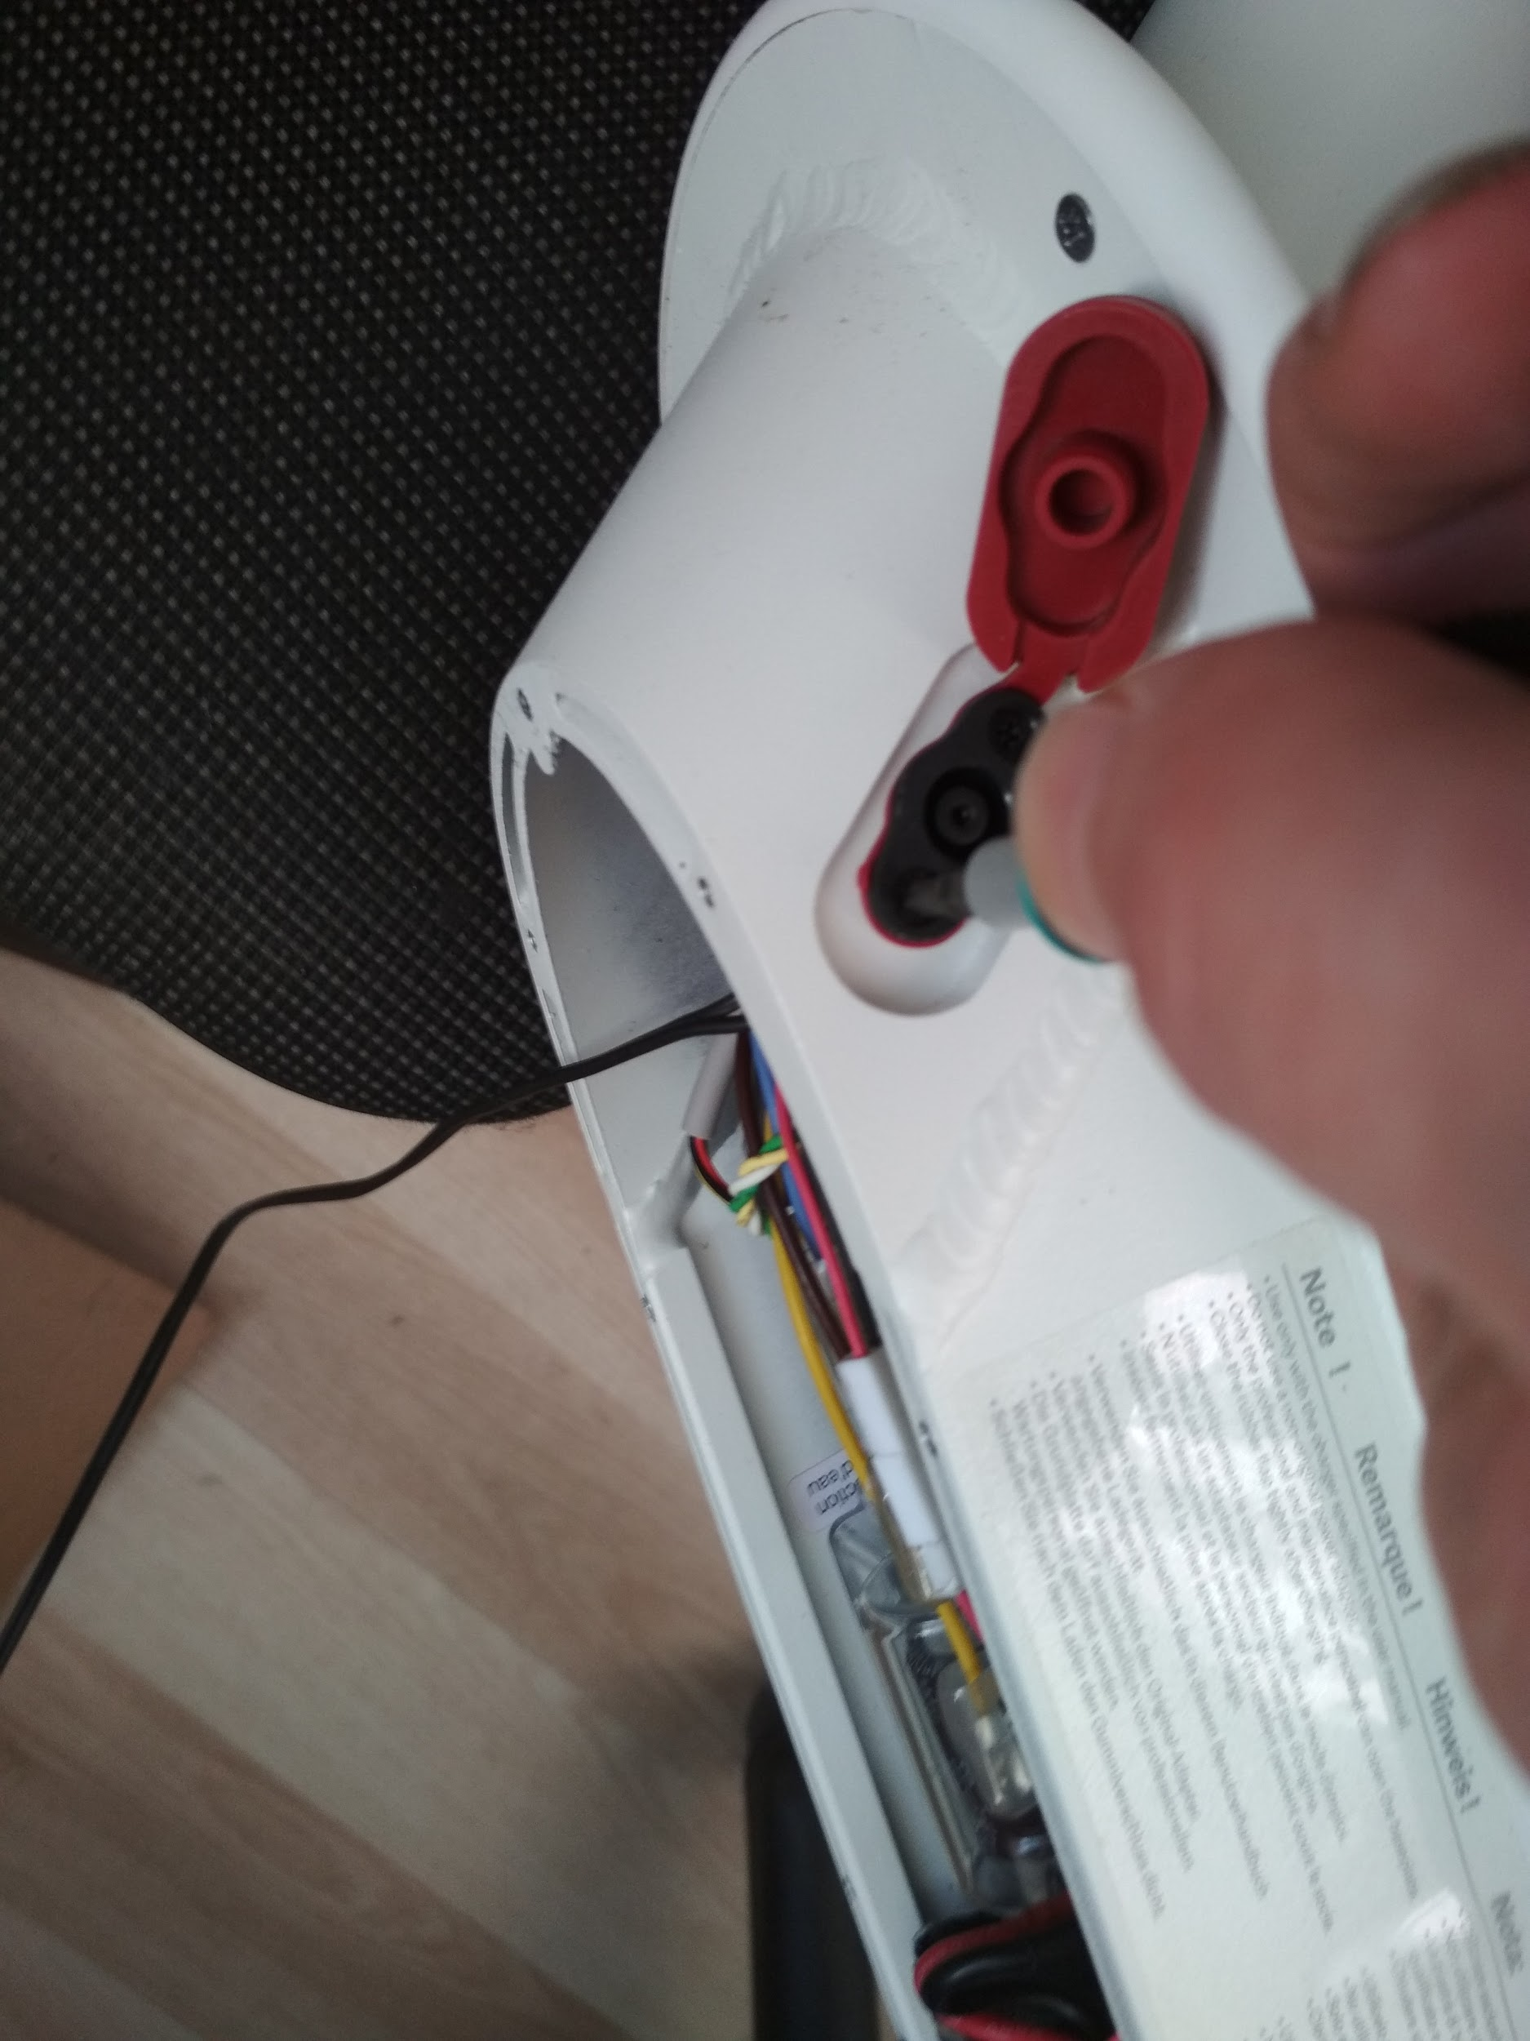

7) Now part of charging cable could be pulled out from the scooter. You should solder 2 wires from Mooving IoT device to charger port as it is shown in the image below. Stripped (or black) wire should be connected with black wire at the charger socket and solid (or red) wire should be connected with red wire at the charger socket. Before soldering please ensure that wire from Mooving IoT device goes through the charger port hole. Use heat shrink tube to isolate and protect connectors and wires after soldering.



8) Mount charger wire back to the hole and fix using a screwdriver.

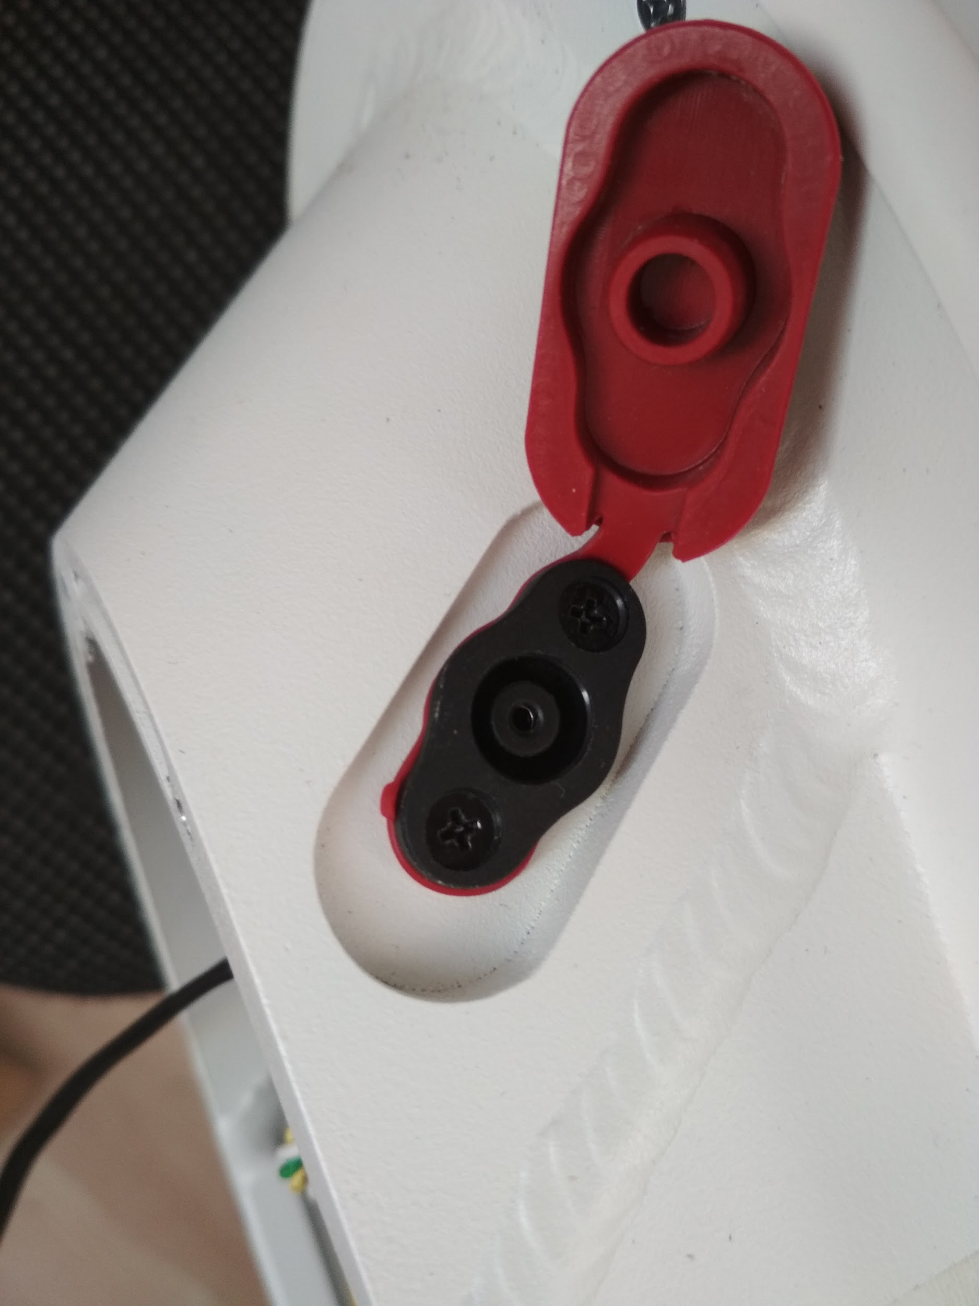

9) Close the bottom lid and fix using a screwdriver.

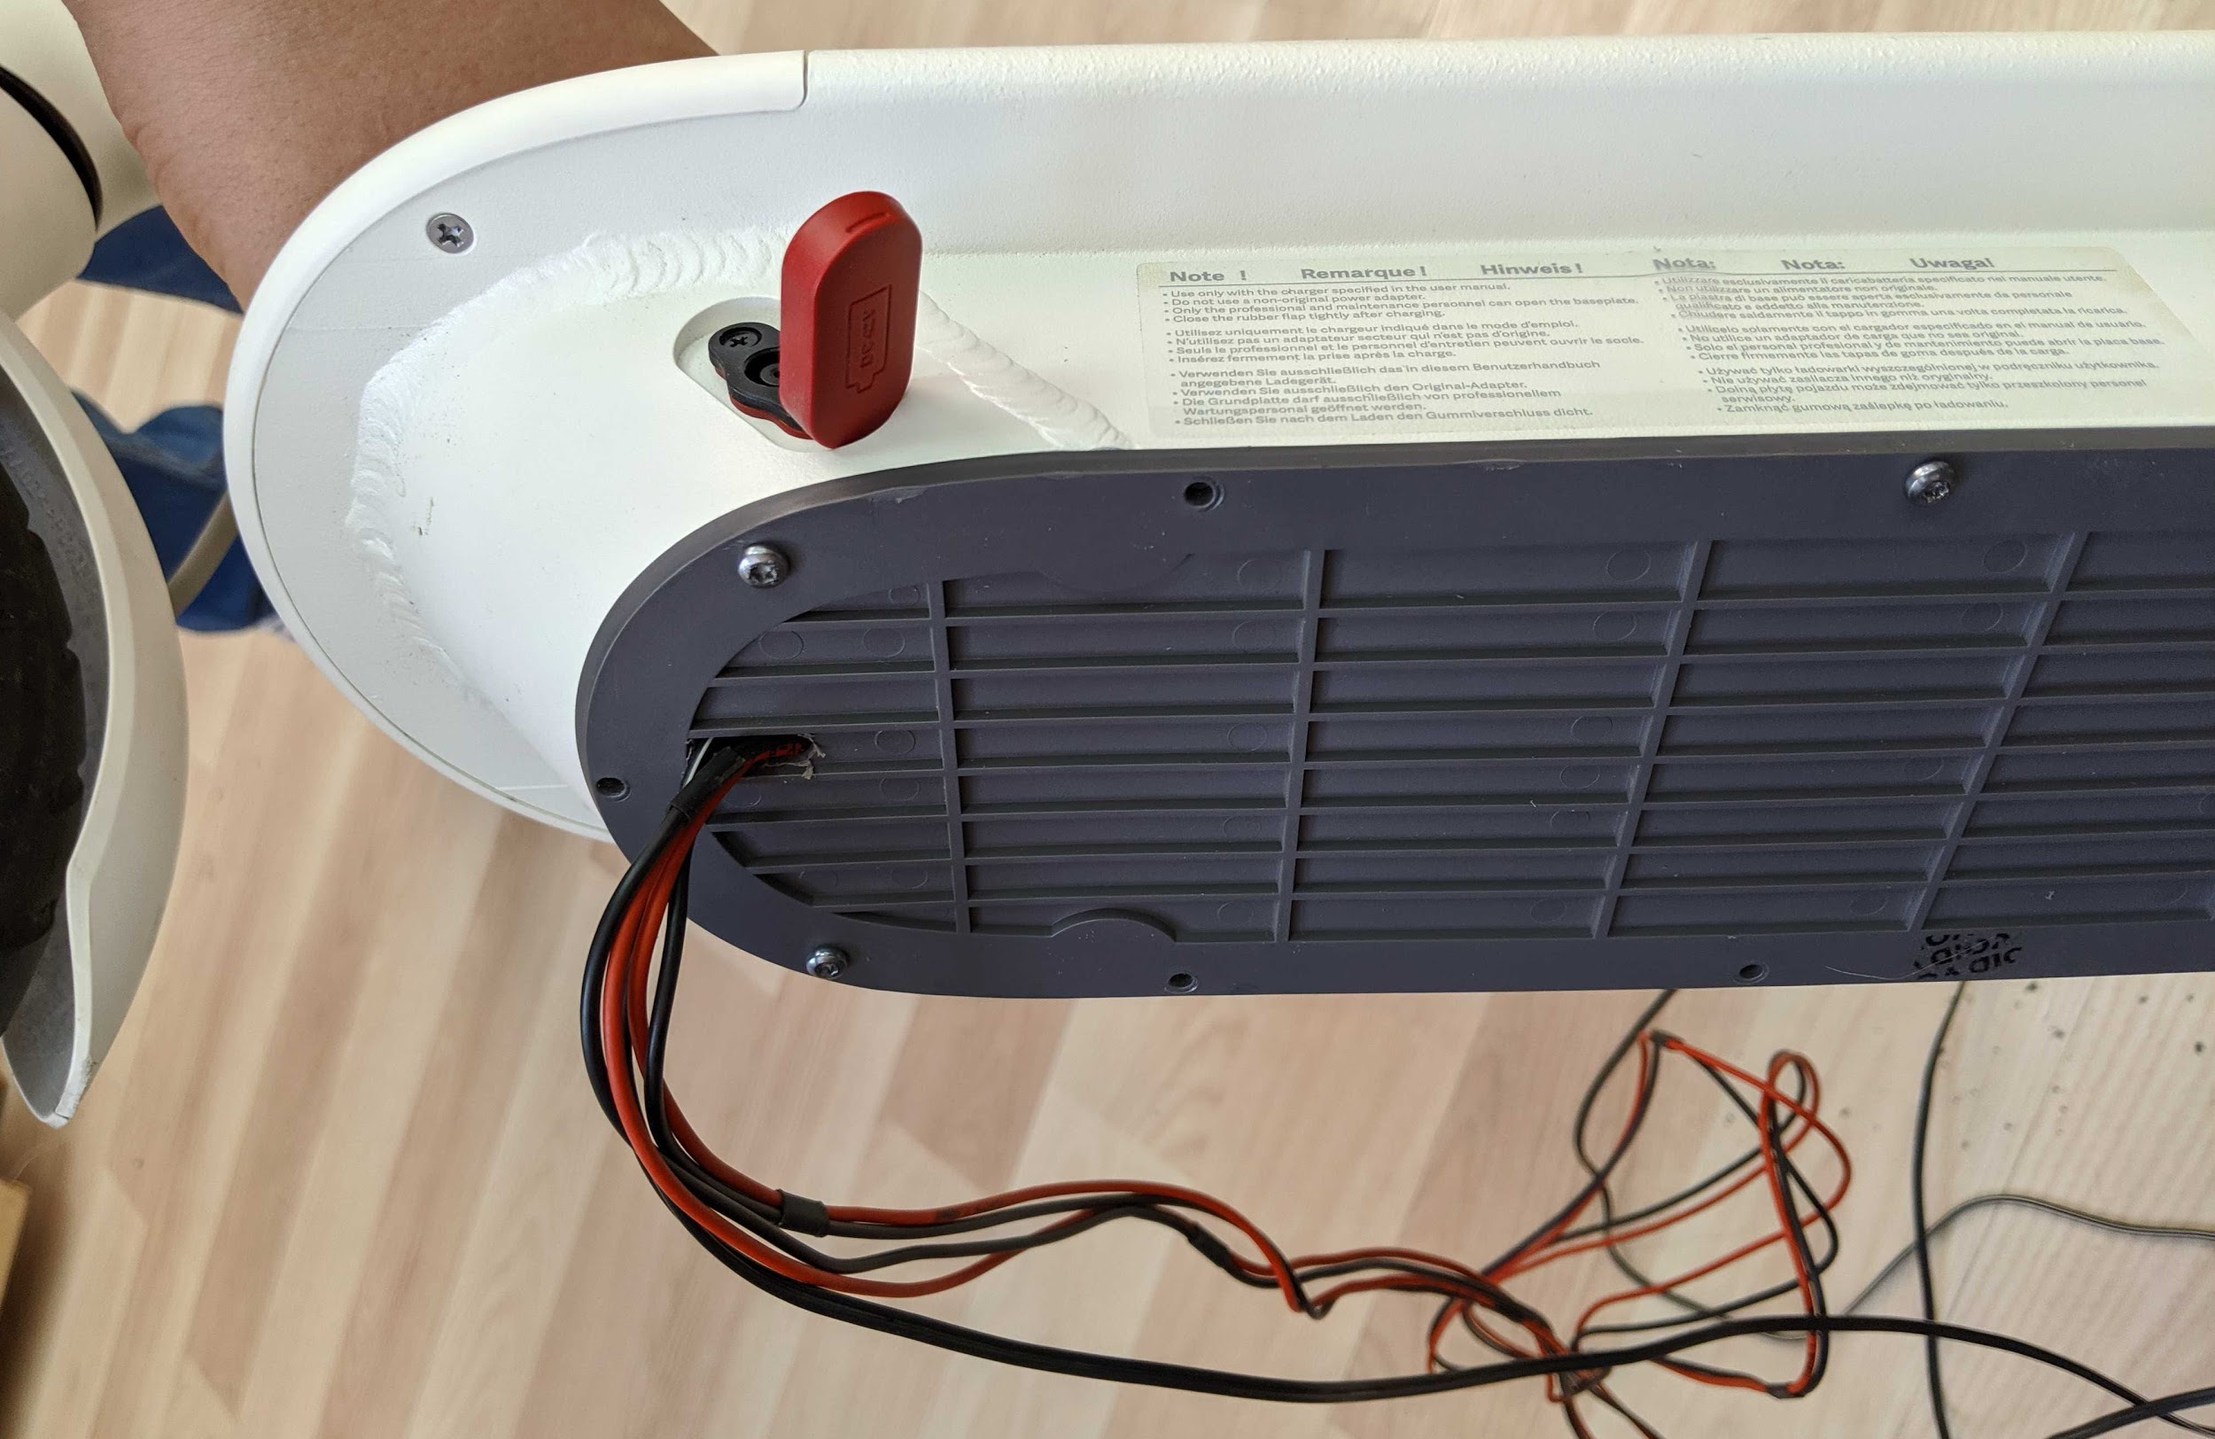

10) Plaсe box with the device on a plane surface. Fix power wires with scotch tape. You should also place the battery and attach the battery connector to the board. We can’t send the device with battery included due to delivery company limitations. You should purchase battery separately.

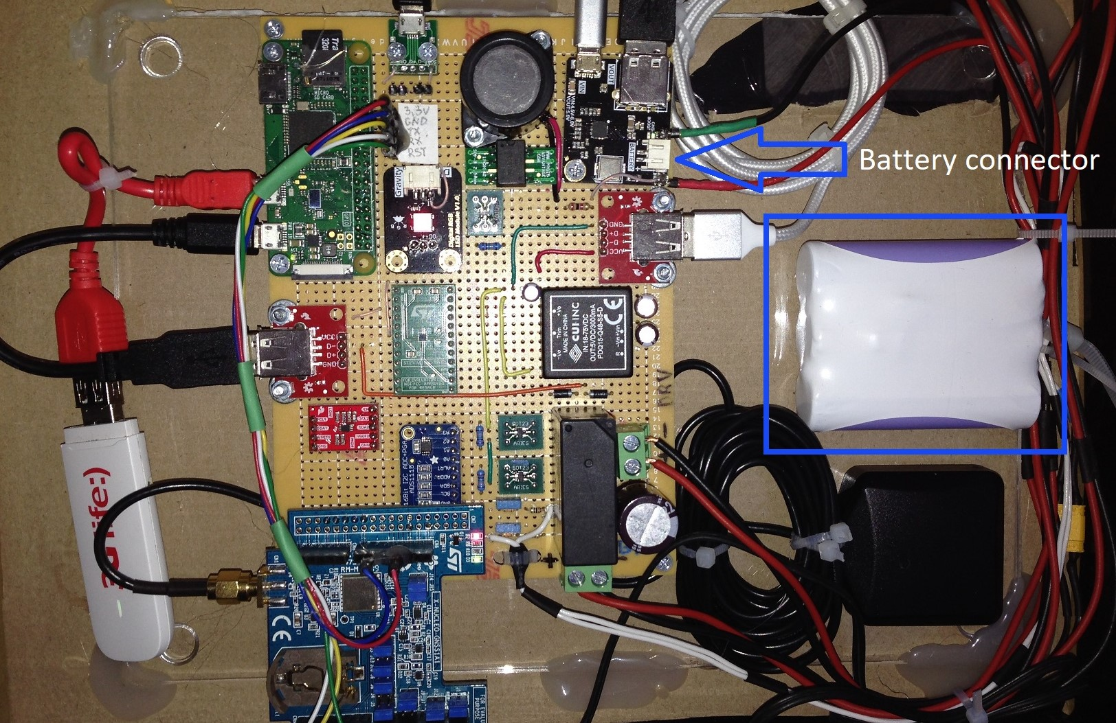

11) Tight box with the device on a plane surface (we used scotch tape for this purpose).

